create database 1bm21cs052_insurance;

use 1bm21cs052_insurance;

SELECT * FROM 1bm21cs052_insurance.person;

create table person(

driver_id varchar(10),

name varchar(20),

address varchar(30),

primary key(driver_id)

);

create table car(

reg_num varchar(10),

model varchar(10),

year int,

primary key(reg_num)

);

create table accident(

report_num int,

accident_date date,

location varchar(20),

primary key(report_num)

);

create table owns(

driver_id varchar(10),

reg_num varchar(10),

primary key(driver_id,reg_num),

foreign key(driver_id) references person(driver_id),

foreign key(reg_num) references car(reg_num)

);

create table participated(

driver_id varchar(10),

reg_num varchar(10),

report_num int,

damage_amount int,

primary key(driver_id,reg_num,report_num),

foreign key(driver_id) references person(driver_id),

foreign key(reg_num) references car(reg_num),

foreign key(report_num) references accident(report_num)

);

insert into person values('A01','Richard','Srinivas nagar');

insert into person values('A02','Pradeep','Rajaji nagar');

insert into person values('A03','Smith','Ashok nagar');

insert into person values('A04','Venu','N R Colony');

insert into person values('A05','Jhon','Hanumanth nagar');

insert into car values('KA052250','Indica','1990');

insert into car values('KA031181','Lancer','1957');

insert into car values('KA095477','Toyota','1998');

insert into car values('KA053408','Honda','2008');

insert into car values('KA041702','Audi','2005');

insert into owns values('A01','KA052250');

insert into owns values('A02','KA031181');

insert into owns values('A03','KA095477');

insert into owns values('A04','KA053408');

insert into owns values('A05','KA041702');

insert into accident values(11,'2003-01-01','Mysore Road');

insert into accident values(12,'2004-02-02','South end circle');

insert into accident values(13,'2003-01-21','Bull Temple Road');

insert into accident values(14,'2008-02-17','Mysore road');

insert into accident values(15,'2004-03-05','Kanakpura road');

insert into participated values('A01','KA052250',11,10000);

insert into participated values('A02','KA053408',12,50000);

insert into participated values('A03','KA095477',13,25000);

insert into participated values('A04','KA031181',14,3000);

insert into participated values('A05','KA041702',15,5000);

**QUERY**

**1)Update the damage amount to 25000 for the car with a specific reg-num for which the accident report number was 12.**

update participated set damage_amount=25000

where reg_num='KA053408' and report_num=12;

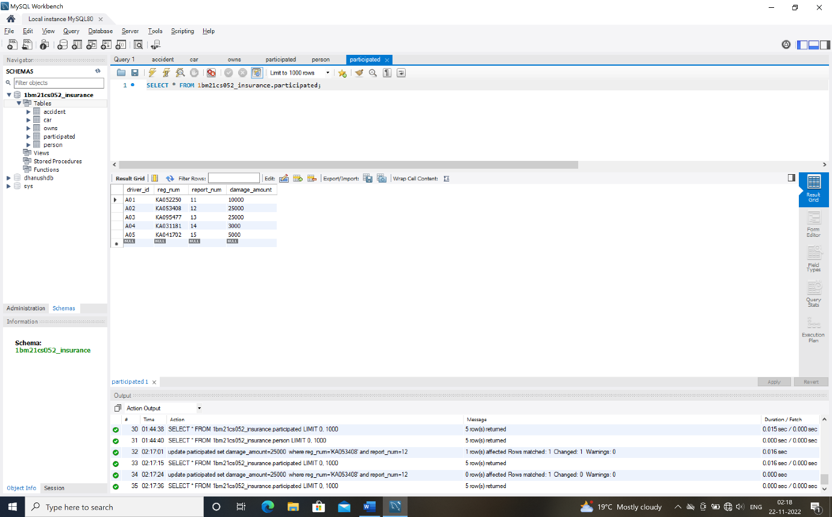

**2)Find the total number of people who owned cars that were involved in accidents in 2008.**

select count(distinct driver_id)CNT

from participated a,accident b

where a.report_num=b.report_num and b.accident_date like '%08%';

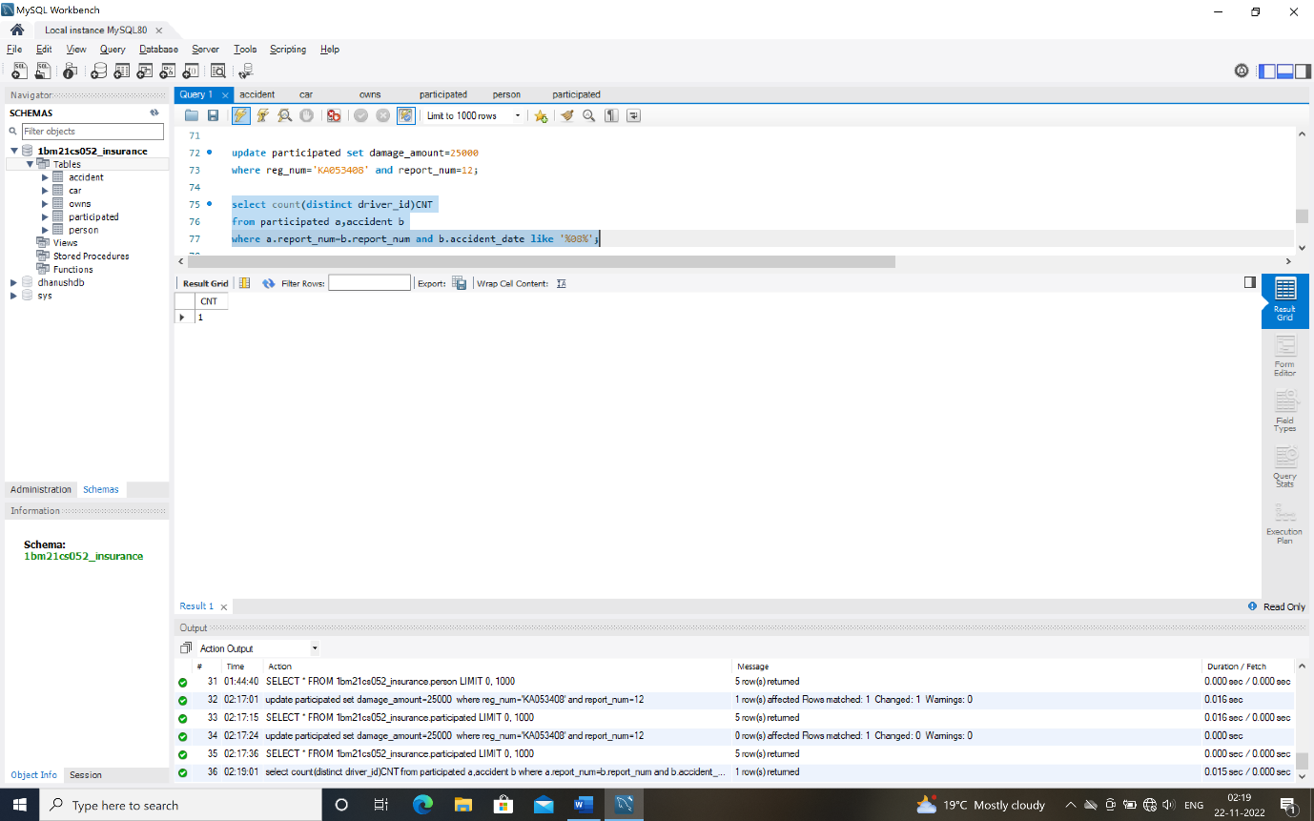

**TO DO**

**1)Display accident date and location.**

insert into accident values(16,'2008-03-08','Domlur');

select*from accident;

select accident_date,location

from insurance.accident;

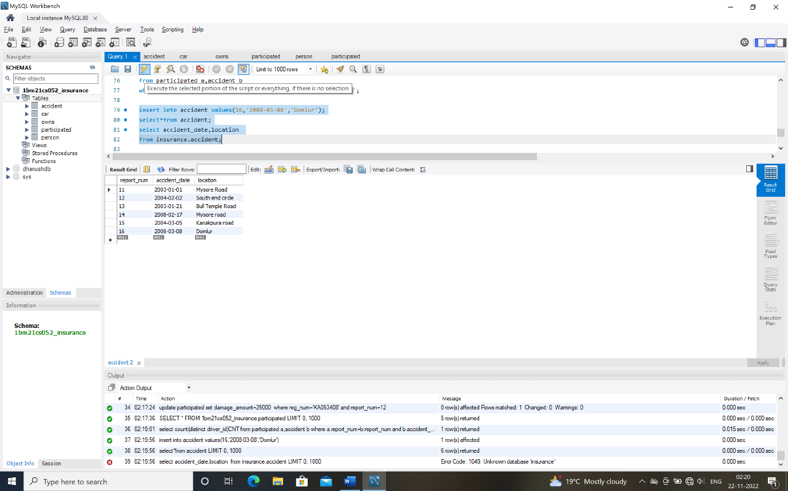

**2)Display driver id who did accident with damage amount greater than or equal to rs.25000.**

select driver_id

from participated

where damage_amount>=25000;

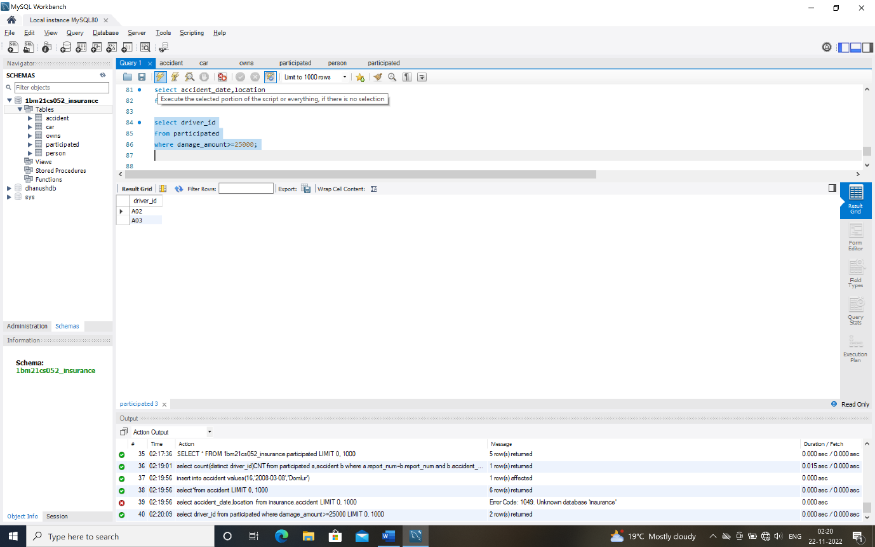

/*week 2*/

**1)Display the entire car relation in the ascending order of manufacturing year.**

select* from car order by year asc;

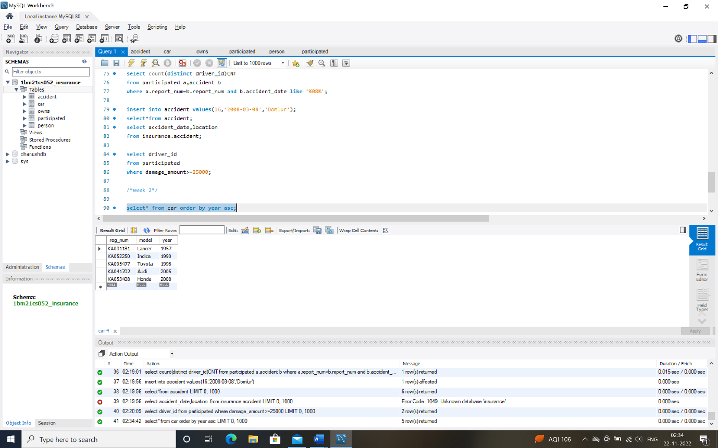

**2)find the number of accidents in which cars belonging to a specific model were involved.**

select count(report_num)

from car c,participated p

where c.reg_num=p.reg_num and c.model='Lancer';

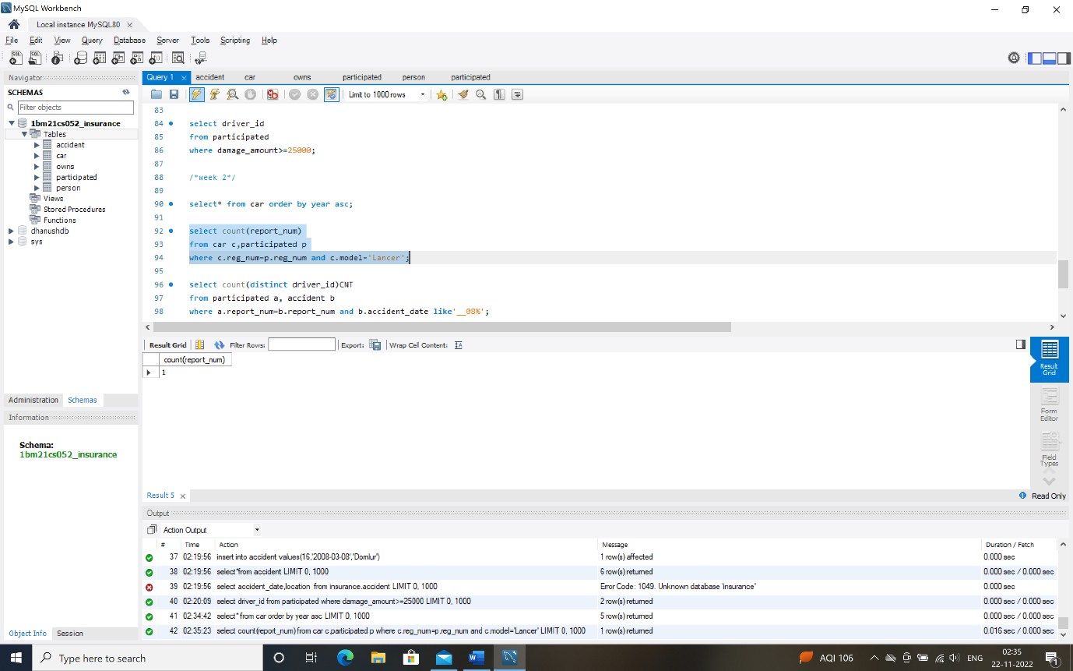

**3)Find the total number of people who owned cars that were involved in accidents in 2008.**

select count(distinct driver_id)CNT

from participated a, accident b

where a.report_num=b.report_num and b.accident_date like'__08%';

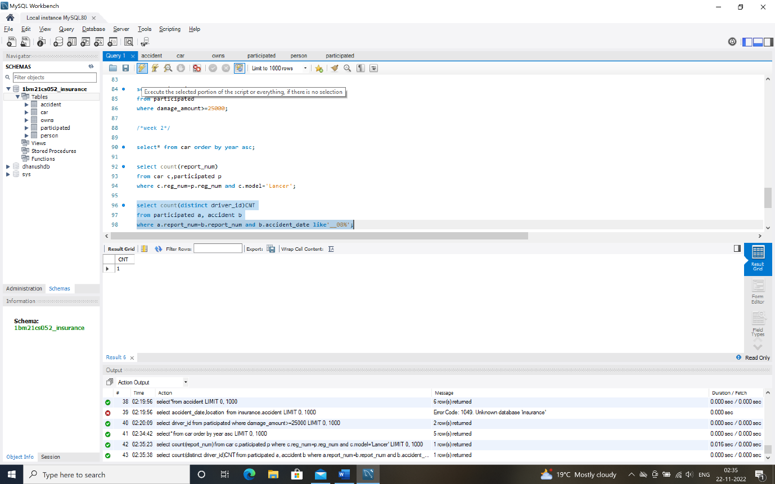

**TO DO**

**1)List the entire participated relation in the descending order of damage amount.**

select*from participated order by damage_amount desc;

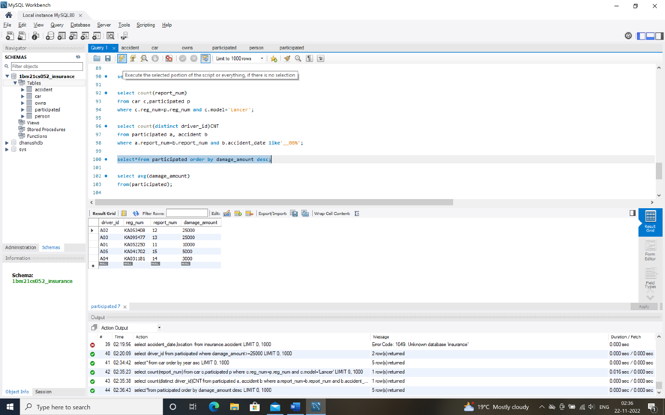

**2)find the average damage amount.**

select avg(damage_amount)

from(participated);

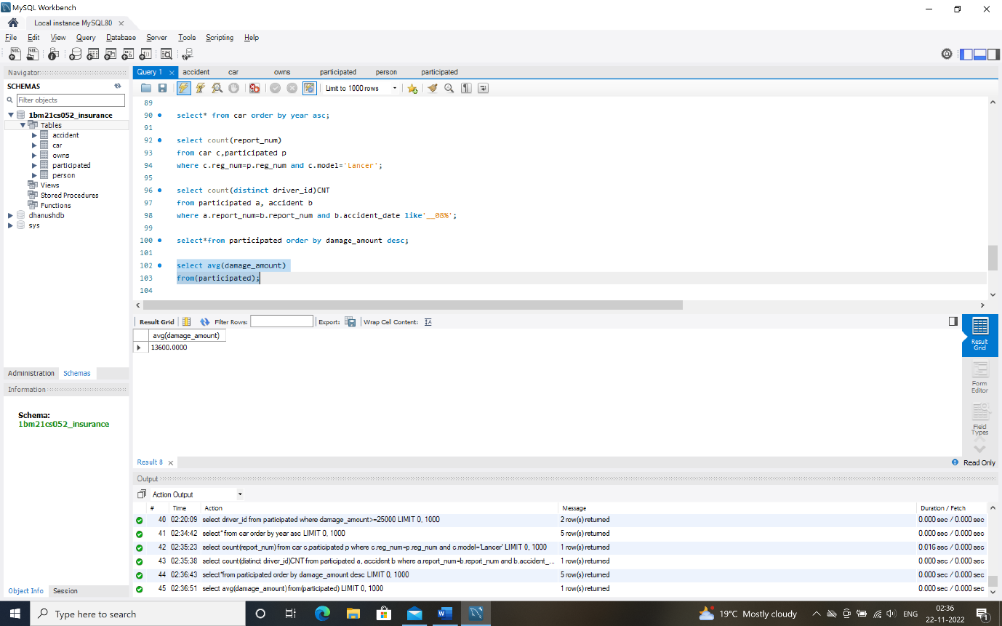

**3)Delete the tuple whose damage amount is below the average damage amount.**

delete from participated where

damage_amount<(select p.damage_amount from(select avg(damage_amount) as damage_amount from participated) p);

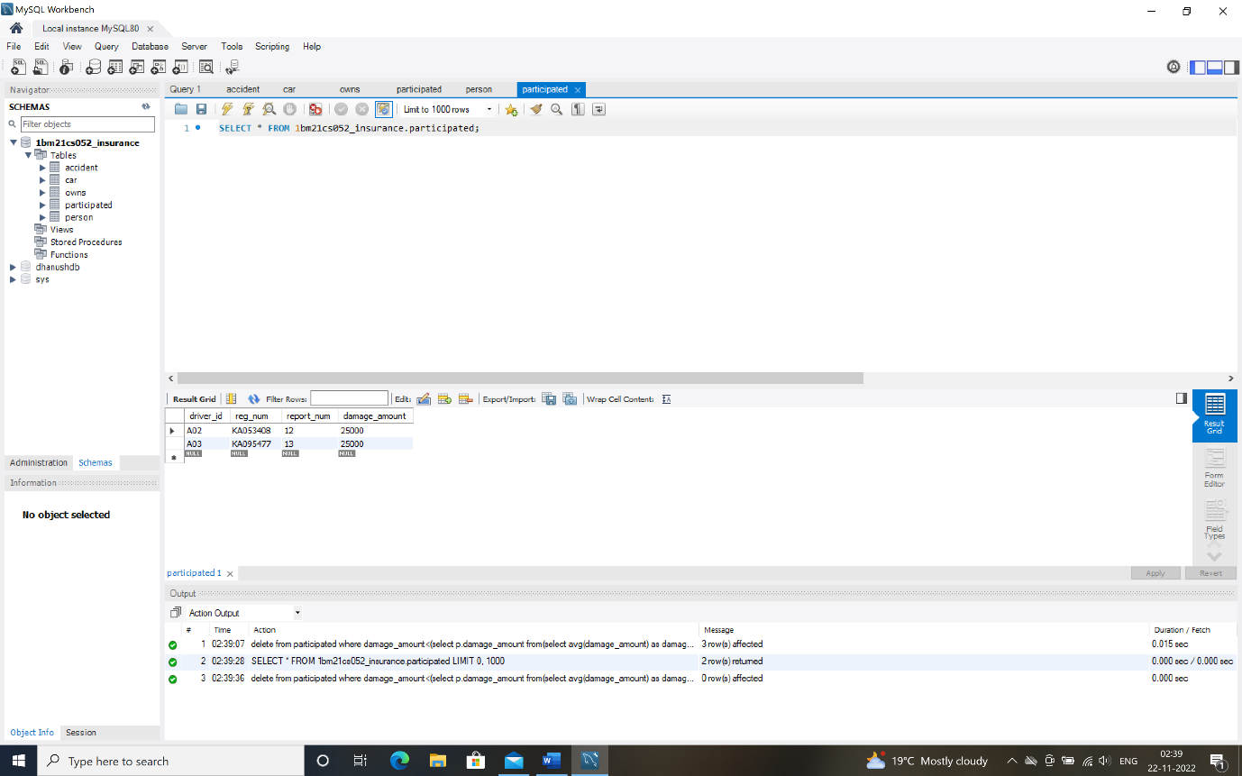

**4)List the name of drivers whose damage is greater than the average damage amount.**

select name from person p,participated part where p.driver_id=part.driver_id and damage_amount>(select avg(damage_amount) from participated);

**5)Find maximum damage amount.**

select MAX(damage_amount) from participated;

